Abstract Title

First (corresponding) A. Author ^{1*}, Second B. Author ²

¹ Institution, address, email address
² Institution, address, email address
Keywords: one, two, three, four, five

Your abstract should be 2 pages and written in English.
Do not include any footnotes or endnotes.
Please submit your abstract as an MS Word file.
Follow the layout of this template, and use Elsevier Harvard name-date format (e.g., Hartig et al., 2003; Kaplan and Kaplan, 1989) for any citations or references.
You may place an acknowledgment statement and one or two references at the end.

Follow this pattern for figures.

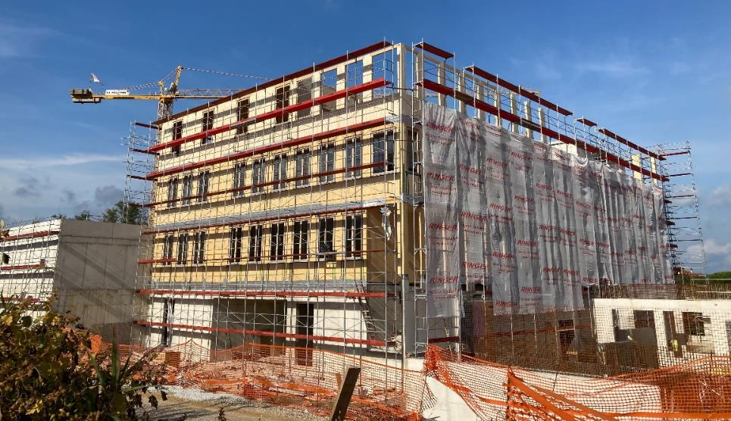
Figure 1: Construction phase of a building

Follow this pattern for tables.

Table 1: Bill of quantities
Column 1 | Column 2 | Column 3
Data 1 | Data 2 | Data 3

Acknowledgment: The authors gratefully acknowledge receiving funding from [funding source, grant number].

REFERENCES
Hartig, T., Evans, G.W., Jamner, L.D., Davis, D.S., Gärling, T., 2003. Tracking restoration in natural and urban field settings. J. Environ. Psychol. 23, 109–123. https://doi.org/10.1016/S0272-4944(02)00109-3
Kaplan, R., Kaplan, S., 1989. The experience of nature: a psychological perspective, 1st ed. Cambridge University Press, Cambridge.

